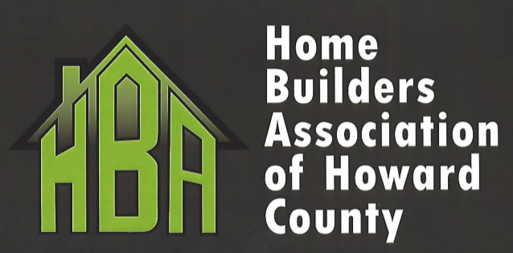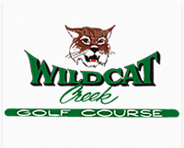

Mike Robinson Memorial Golf Outing

Wednesday, June 13 , 2018

1:00pm Shotgun Start

Putting Contest 12:00 – 1:00pm
Putting Contest and Circle Hole $50 to each Winner

$5000 hole in one contest
MUST HAVE A VOLUNTEER(S) TO MONITOR MONEY HOLE FOR ENTIRE EVENT
Sponsored by: Hague Quality Water of Kokomo

$400 per Team Includes: Golf & Cart, Dinner, 2 Drinks
Mulligan 1 per golfer-Tee only

Individual Golf & Dinner: $100 Dinner Only: $20
Event sponsorship 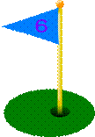
- Drink Cart Sponsor $250.00
- Dinner and Drink Sponsor $200.00
- Exclusive Hole Sponsor $100.00
- Course Sponsor $ 50.00

VOLUNTEERS AND DOOR PRIZES NEEDED
Any questions, please call the HBA office at 765-236-0694 or

RICK MILLER 765-438-4247

Mike Robinson Memorial Golf Outing
TEAM REGISTRATION $400.00
(1 player must be hba member)

1.__________________________ 2.________________________

3.___________________________ 4.________________________
OR
Individual golf and dinner $100.00 dinner only $20.00
______________________________ _________________________
NAME NAME

VOLUNTEER(S)
NAME | AVAILABLE | TIMES
 |  | 11 PM -1 PM
 |  | 1 PM – 3PM
 |  | 3 PM – 5 PM
 |  | 5 PM – 630 PM
 |  | NOON – 5 PM
 |  | ALL DAY
 |  | OTHER (Please list your availability)

Event sponsorship
_____ Drink Cart Sponsor $250.00
_____ Dinner and Drink Sponsor $200.00
_____ Exclusive Hole Sponsor $100.00
_____ Course Sponsor $ 50.00

Please send payment for sponsorship / registration to:

HBA of Howard Co. P.O. Box 1187 Kokomo, IN 46903

Office 765-236-0694 Rick Miller 765-438-4247

Email hbahowardco@outlook.com

